Develop Environment

- Installing the Arduino IDE

When we get control board, we need to download Arduino IDE and driver firstly.
You could download Arduino IDE from the official website:
https://www.arduino.cc/, click the SOFTWARE on the browse bar, click“DOWNLOADS” to enter download page, as shown below:
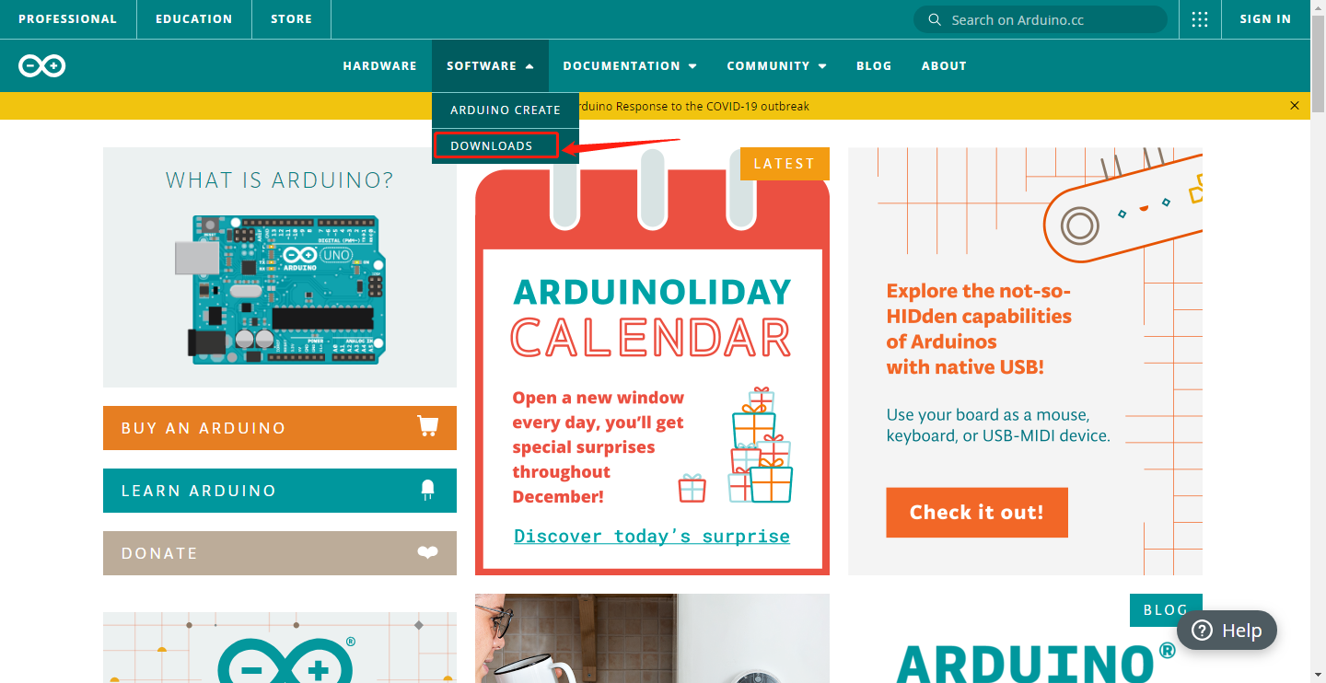
There are various versions of IDE for Arduino. Just download a version compatible with your system. Here we will show you how to download and install the windows version of Arduino IDE.
There are two versions of IDE for Windows system: Windows Win7 and newer and Windows ZIP file. The former needs to install manually, while the latter can be directly downloaded, without the need of installing it manually.
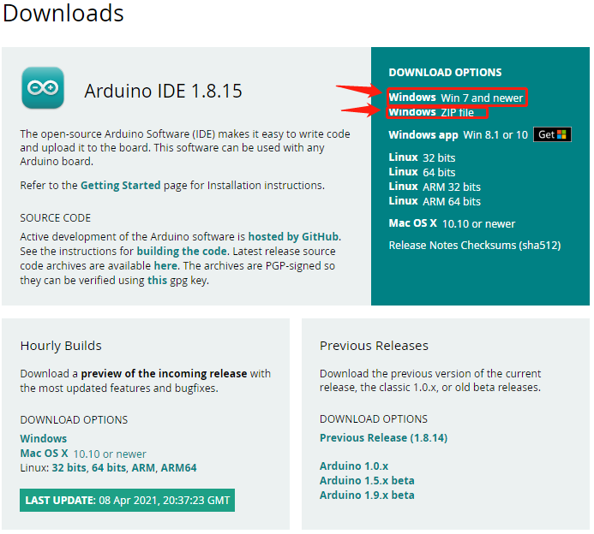

You just need to click JUST DOWNLOAD.

- Installing the driver

In Windows10, insert Pico, the system will automatically identify the serial port, and install the corresponding driver, then you can find the "USB serial device" in the device manager.
If your computer is still running Windows 7, when you plug the Raspberry Pi Pico into the USB port, your computer will find a "Board CDC" device, but it can't automatically recognize it or install drivers.
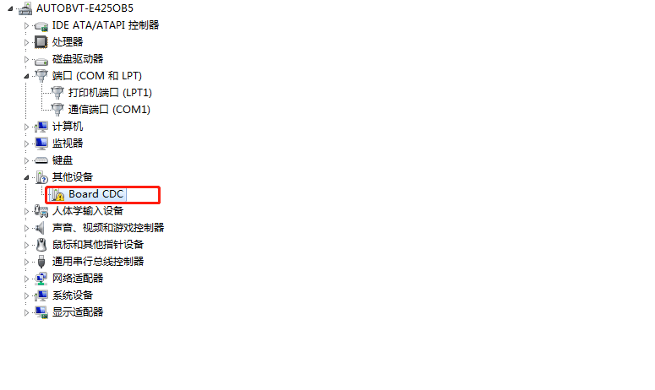
First, we need to create a new text document and enter the following content in it:
; Windows 2000, XP, Vista, 7 and 8 (x32 and x64) setup file for Atmel CDC Devices
; Copyright (c) 2000-2013 ATMEL, Inc.

[Version]
Signature = "$Windows NT$"
Class = Ports
ClassGuid = {4D36E978-E325-11CE-BFC1-08002BE10318}

Provider = %Manufacturer%
LayoutFile = layout.inf
CatalogFile = atmel_devices_cdc.cat
DriverVer = 01/08/2013,6.0.0.0

;----------------------------------------------------------
; Targets
;----------------------------------------------------------
[Manufacturer]
%Manufacturer%=DeviceList, NTAMD64, NTIA64, NT

[DeviceList]
%PI_CDC_PICO%=DriverInstall, USB\VID_2E8A&PID_0005&MI_00

[DeviceList.NTAMD64]
%PI_CDC_PICO%=DriverInstall, USB\VID_2E8A&PID_0005&MI_00

[DeviceList.NTIA64]
%PI_CDC_PICO%=DriverInstall, USB\VID_2E8A&PID_0005&MI_00

[DeviceList.NT]
%PI_CDC_PICO%=DriverInstall, USB\VID_2E8A&PID_0005&MI_00

;----------------------------------------------------------
; Windows 2000, XP, Vista, Windows 7, Windows 8 - 32bit
;----------------------------------------------------------
[Reader_Install.NTx86]

[DestinationDirs]
DefaultDestDir=12
DriverInstall.NT.Copy=12

[DriverInstall.NT]
include=mdmcpq.inf
CopyFiles=DriverInstall.NT.Copy
AddReg=DriverInstall.NT.AddReg

[DriverInstall.NT.Copy]
usbser.sys

[DriverInstall.NT.AddReg]
HKR,,DevLoader,,*ntkern
HKR,,NTMPDriver,,usbser.sys
HKR,,EnumPropPages32,,"MsPorts.dll,SerialPortPropPageProvider"

[DriverInstall.NT.Services]
AddService = usbser, 0x00000002, DriverService.NT

[DriverService.NT]
DisplayName = %Serial.SvcDesc%
ServiceType = 1 ; SERVICE_KERNEL_DRIVER
StartType = 3 ; SERVICE_DEMAND_START
ErrorControl = 1 ; SERVICE_ERROR_NORMAL
ServiceBinary = %12%\usbser.sys
LoadOrderGroup = Base

;----------------------------------------------------------
; Windows XP, Vista, Windows 7, Windows 8 - 64bit
;----------------------------------------------------------

[DriverInstall.NTamd64]
include=mdmcpq.inf
CopyFiles=DriverCopyFiles.NTamd64
AddReg=DriverInstall.NTamd64.AddReg

[DriverCopyFiles.NTamd64]
usbser.sys,,,0x20

[DriverInstall.NTamd64.AddReg]
HKR,,DevLoader,,*ntkern
HKR,,NTMPDriver,,usbser.sys
HKR,,EnumPropPages32,,"MsPorts.dll,SerialPortPropPageProvider"

[DriverInstall.NTamd64.Services]
AddService=usbser, 0x00000002, DriverService.NTamd64

[DriverService.NTamd64]
DisplayName=%Serial.SvcDesc%
ServiceType=1
StartType=3
ErrorControl=1
ServiceBinary=%12%\usbser.sys

;----------------------------------------------------------
; String
;----------------------------------------------------------

[Strings]
Manufacturer = "ATMEL, Inc."
PI_CDC_PICO = "Pi Pico Serial Port"

Serial.SvcDesc = "Pi Pico Serial Driver"
Then save the file named "Board CDC_RP2_pico-serial" in the. Inf format, which is the driver file , and manually add the driver to the unrecognized device in device manager.
Open the device manager on your computer: double-click or right-click on the hardware to update the driver.
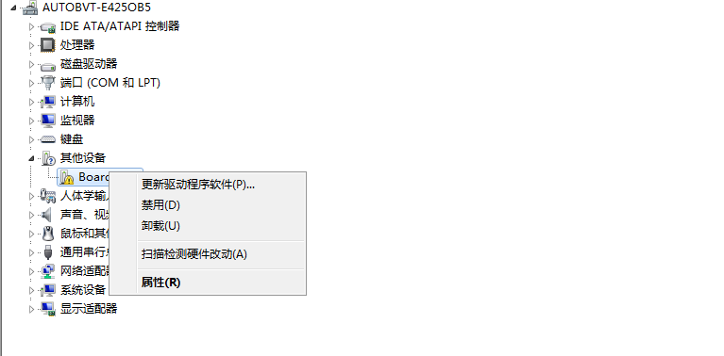

Browse the computer for drivers
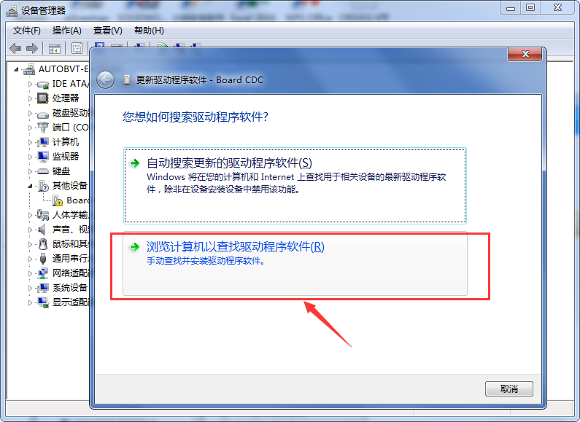
Assuming that our driver file is on the desktop, then we need to go to the corresponding folder and click Next.
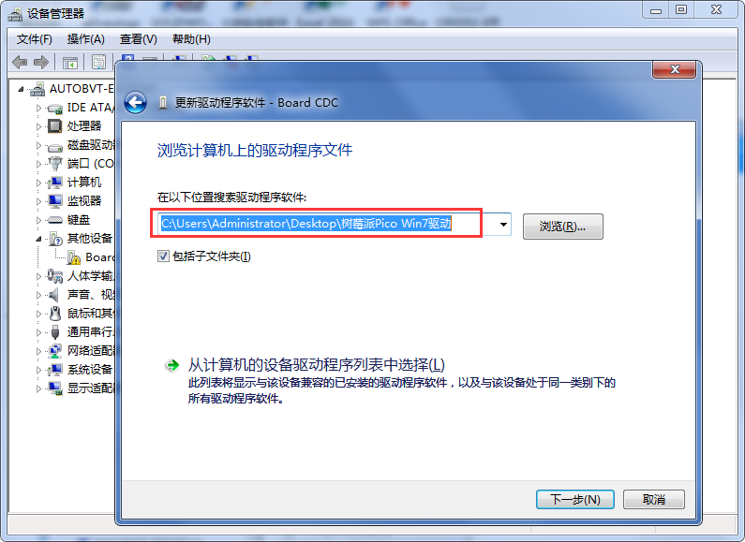

Select this folder and click Next.
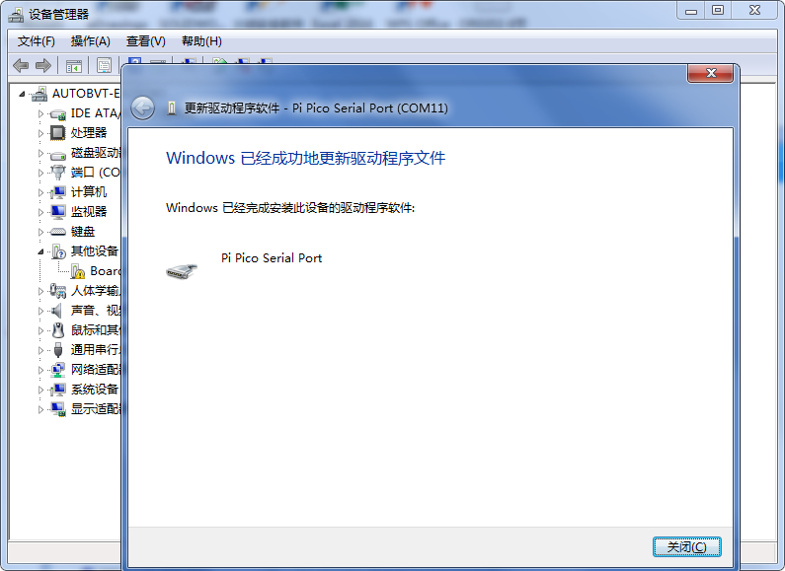
Open the device Manager, we can see that the driver of the Pi Pico has been successfully installed, the Pi Pico Serial Port appears.
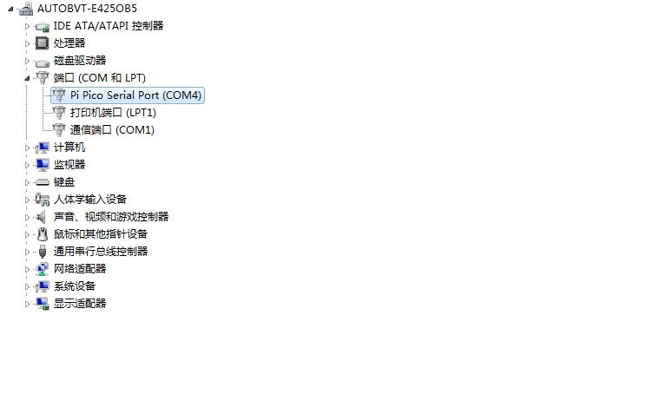

- Arduino IDE Setting

Click icon and open the Arduino IDE.
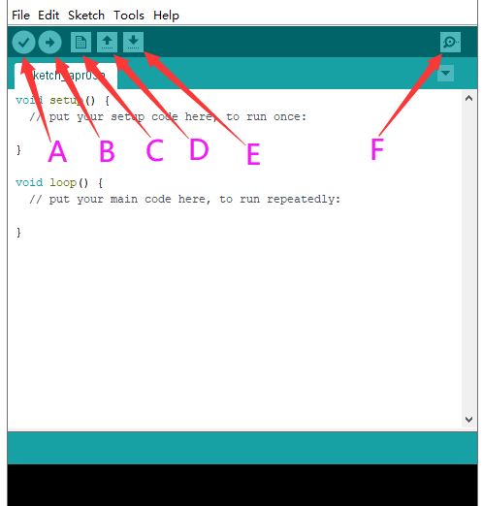
A- Used to verify whether there is any compiling mistakes or not.
B- Used to upload the sketch to your Arduino board.
C- Used to create shortcut window of a new sketch.
D- Used to directly open an example sketch.
E- Used to save the sketch.
F- Used to send the serial data received from board to the serial monitor.

Set the pico environment(information：
https://github.com/earlephilhower/arduino-pico)
Select(File) → (Preferences)
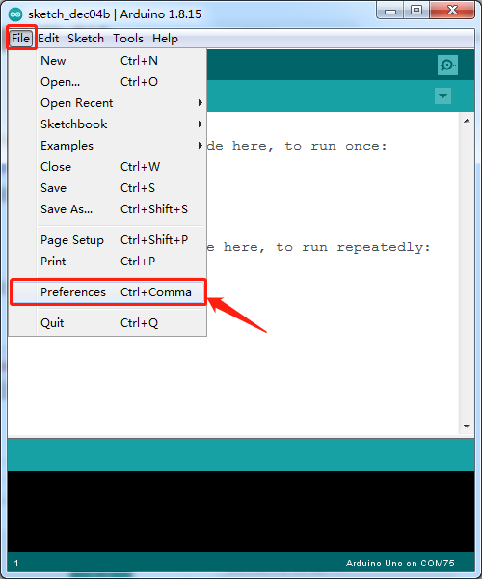
Enter the URL in the「Additional Boards Manager URLs」https://github.com/earlephilhower/arduino-pico/releases/download/global/package_rp2040_index.json
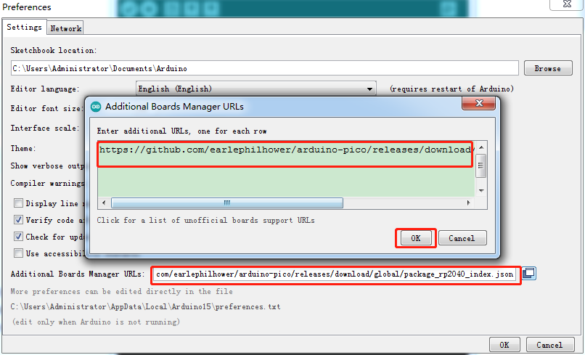
Click OK
Select (Tools)→ (Board) → (Board Manager)
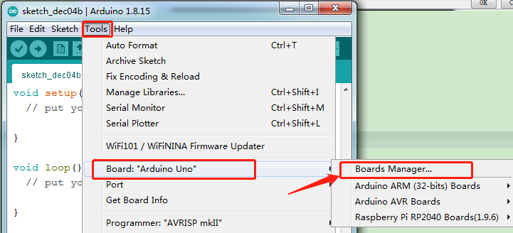
Enter pico in the search area, the following screen will appear, and then click Install.
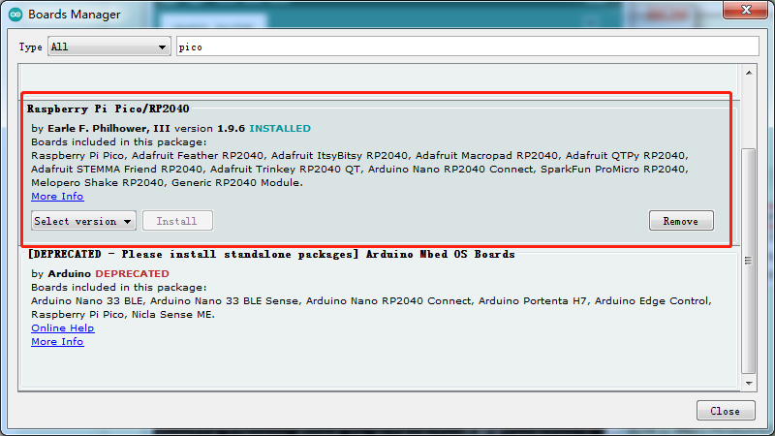
The IDE is already installed.

Then select(Tools)→ (Board) → Raspberry Pi RP2040 Boards(1.9.6) → Raspberry Pi Pico.

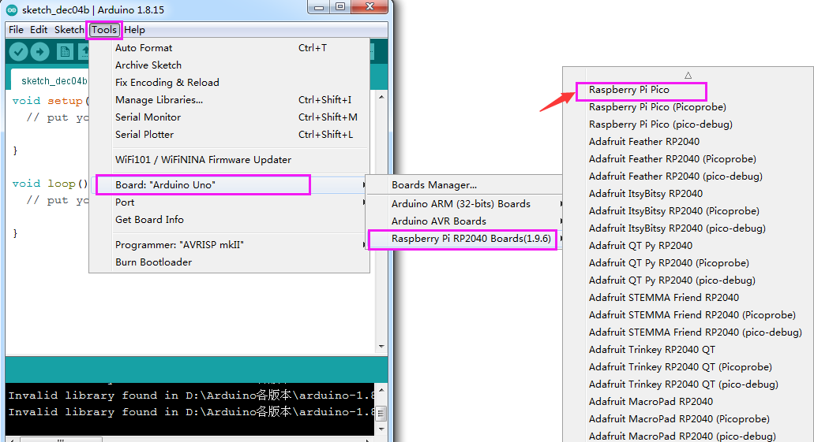
After selecting the development board, select the Port to connect to Pico.
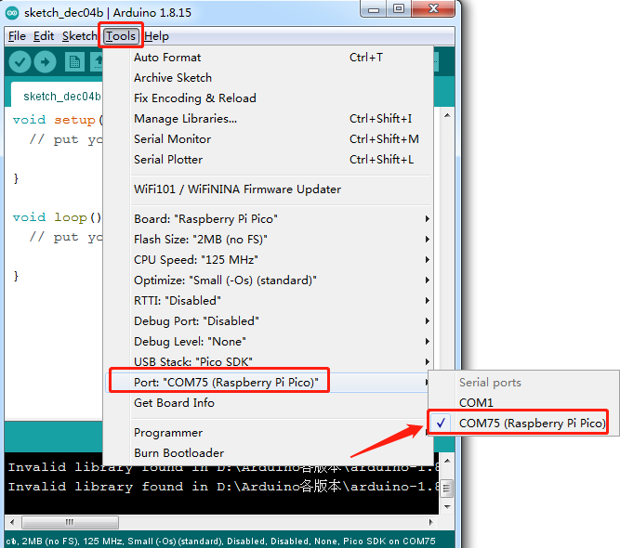

- Start your first program

Here we will use the internal example code to make the onboard LED lights show the change of light and shade:
Select(File)→ (Examples)→ rp2040→ Fade
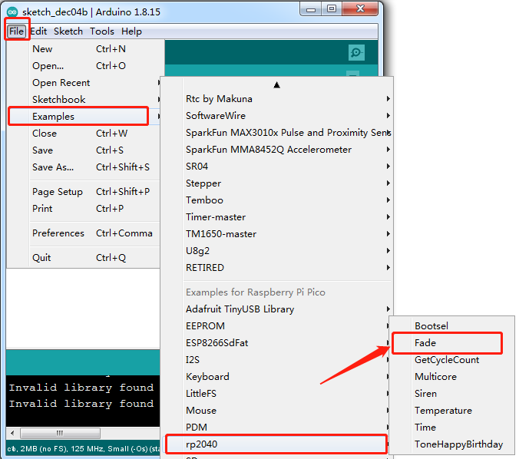
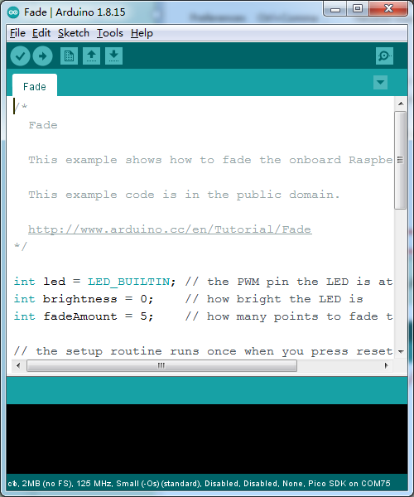

Note:
(1)Disconnect Pi Pico USB first
(2) Press and hold the white BOOTSEL button on the development board, then plug in the USB power.
(3)Click under Arduino IDE to compile and upload the development board.
(4) Compiling "Compiling Sketch..." , release the BOOTSEL button
when“Uploading...”appears.
(5) When“Done uploading”appears, then it has been completed.
Pay attention to this sequence during the first upload process, otherwise it will fail to upload. Select the corresponding port for the subsequent upload and click upload. Once the upload is complete, you can see the LED on the development board ranging from dark to bright and back again and again like the LED breathing.

- Installing the library files
First, find the Arduino library folder:
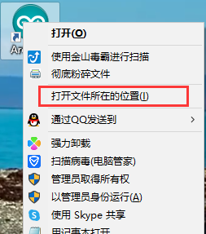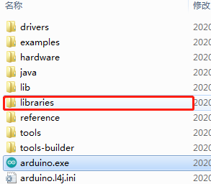
Then replicate the library files needed into this folder.

